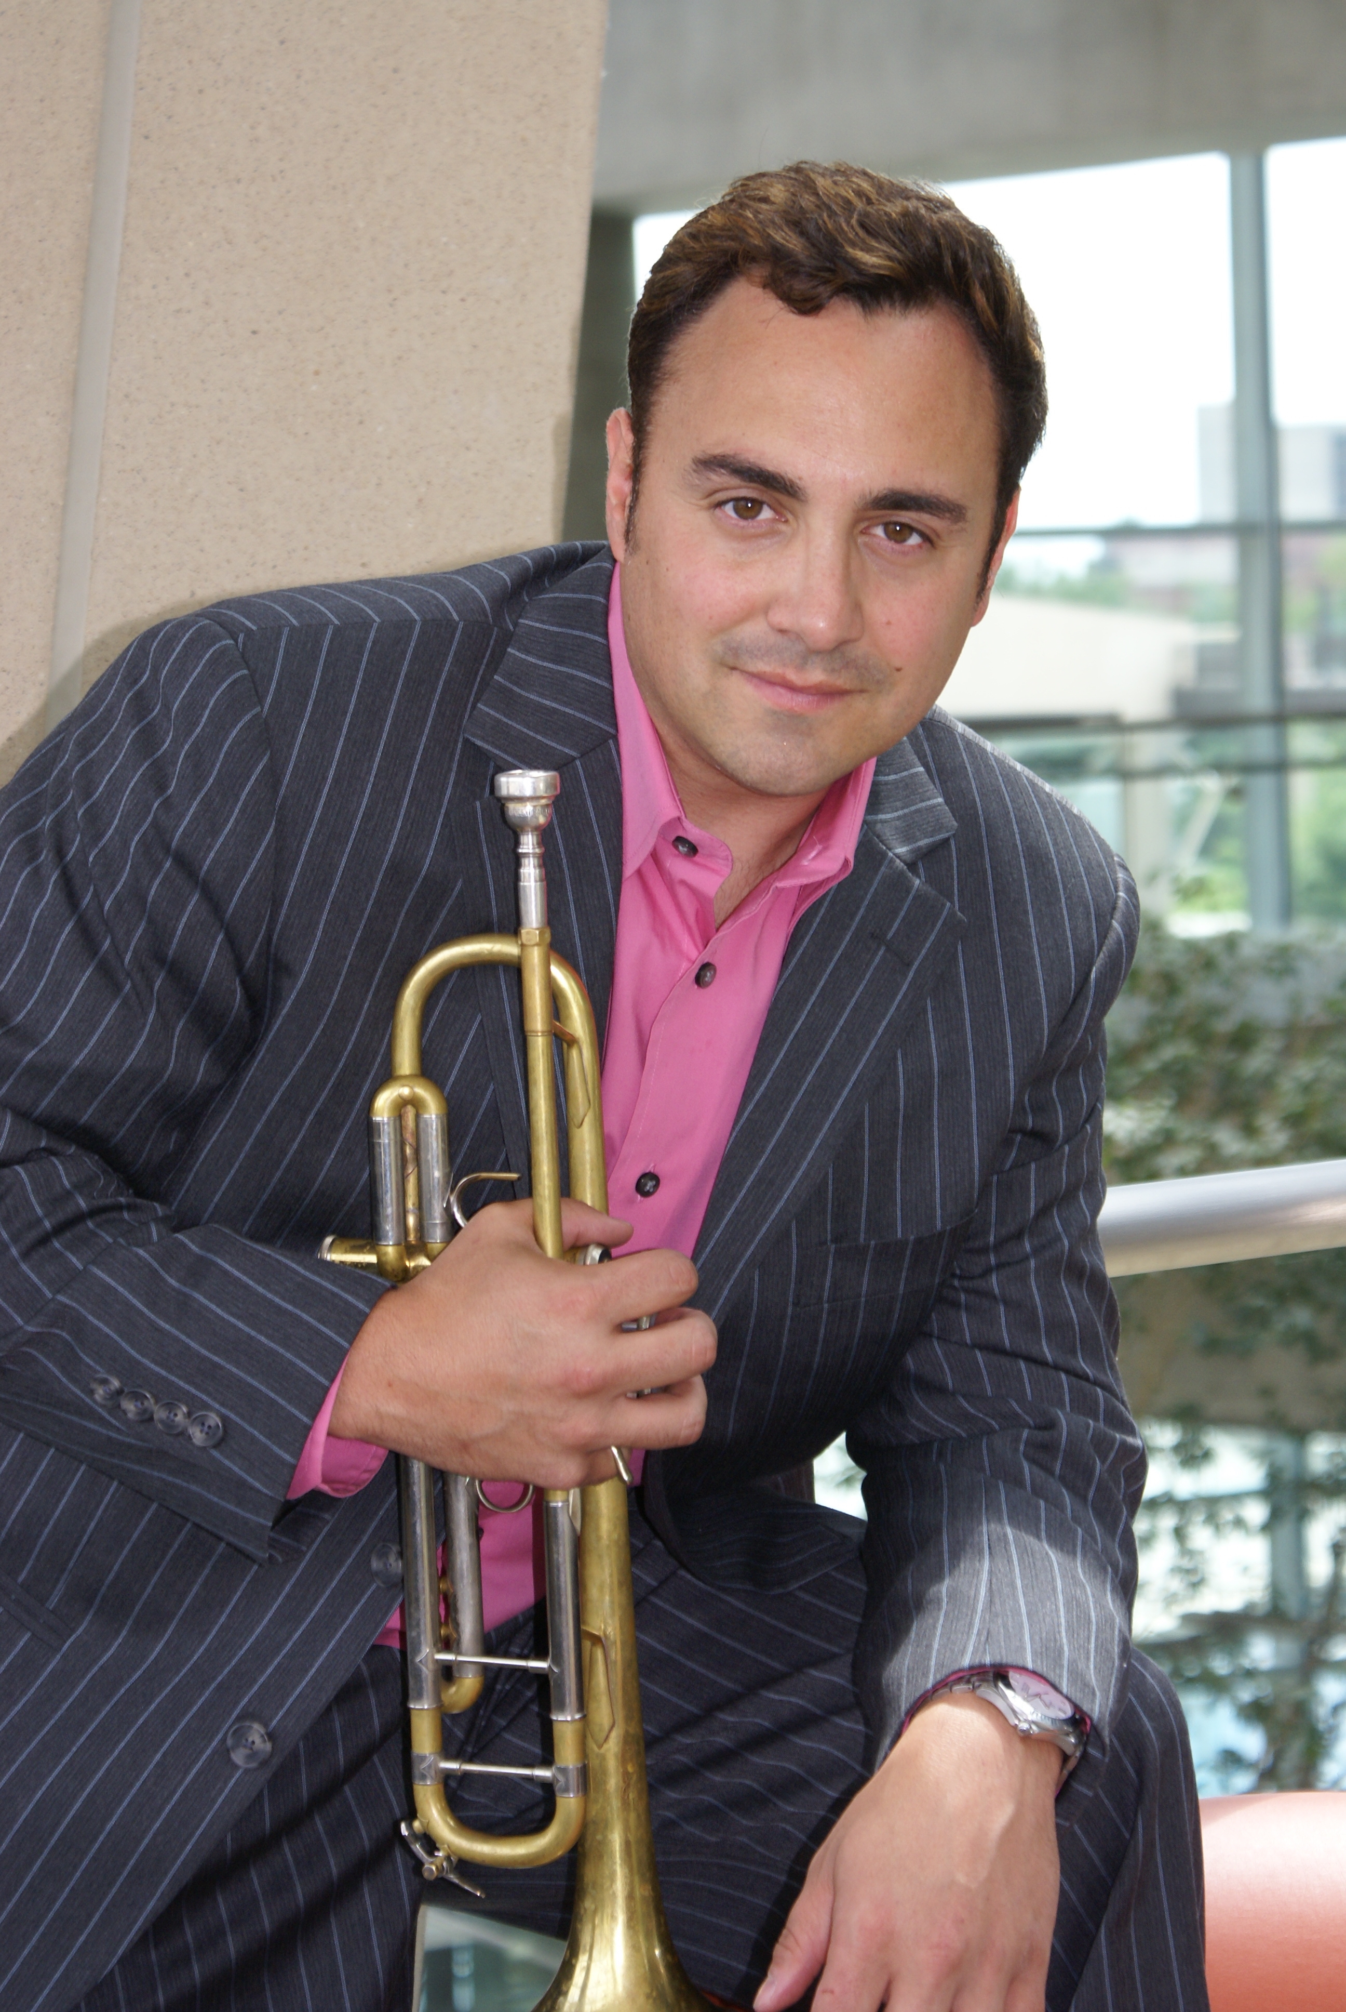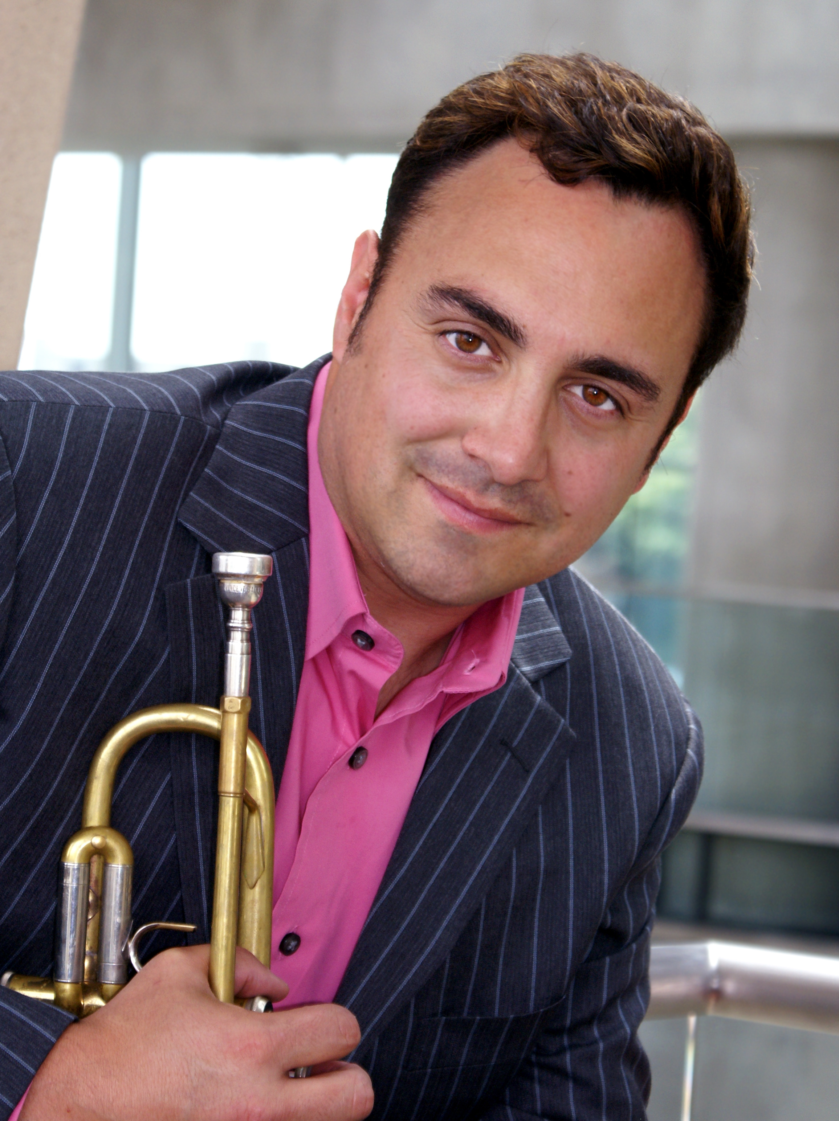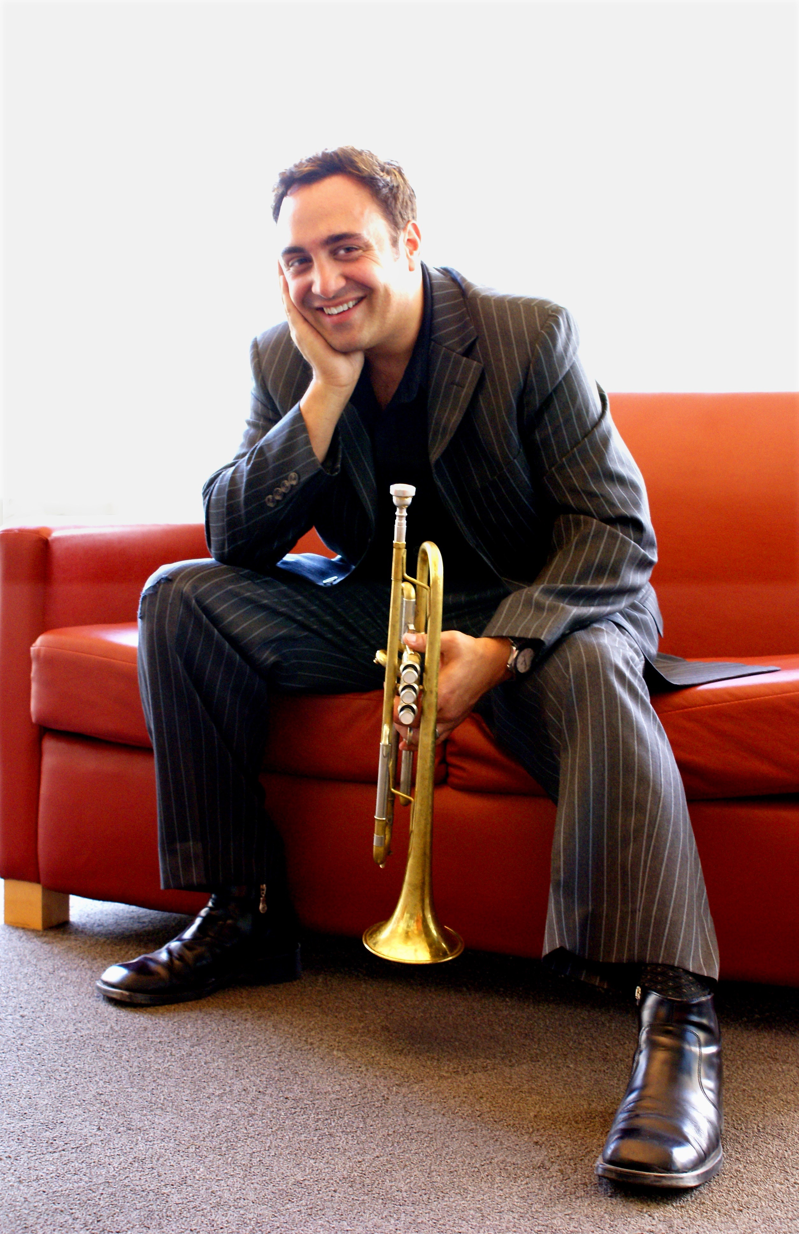

Anthony DiLorenzo

Emmy Award winning composer, trumpet soloist, and Grammy nominated recording artist Anthony DiLorenzo, has established himself as one of the most exciting up and coming composers of today. His bold and stylish music is performed throughout the world with the most renowned orchestras including The San Francisco Symphony, The New World Symphony, The Louisiana Philharmonic, The Utah Symphony, The Tokyo Symphony and The Boston Pops Orchestra.

Anthony’s career began growing in popularity in the 1990’s with his original compositions written for brass. His brass quintet ‘Fire Dance’ has become one of many standards used in competitions and Universities throughout the world. Some of his other popular works include Nexus, Go, A Little Russian Circus, The Blade of Spain, Phoenix, Jabberwocky, Colossus, John Adams ‘Voice Heard Round’, and his ballet Dracula ‘The Seduction’, which was staged three times with the Sacramento Ballet Company.

Anthony attended The Curtis Institute of Music and participated in festivals such as Tanglewood where he received the Harry Shapiro Award for outstanding musician and was nominated by Leonard Bernstein for an Avery Fischer Career Grant Award. His trumpet took him to hold positions in The New World Symphony, The Philadelphia Orchestra, The Santa Fe Opera, and The Utah Symphony. He was also a founding member of The Center City Brass Quintet and Proteus 7 Ensemble.

In addition to DiLorenzo’s original works for the concert stage, his work in film and television spans thirty years. Shortly after graduating and while playing principal trumpet with the Utah Symphony Orchestra, Anthony found his way into the film world writing more than one hundred film trailers, including those for Toy Story, Forrest Gump, 101 Dalmatians, The League of Extraordinary Gentlemen, Red Dragon, The Lost World, Final Fantasy, Fools Gold, Bee Story, Flubber, Kung Fu Panda, The Harry Potter series and Iron Giant. As his film career grew he added several original scores to his credits such as Benji Off The Leash, The Chosen One, Meltdown and most recently Bathtubs Over Broadway.

From 1992-2017 DiLorenzo’s catchy original themes were heard on ABC network’s College Football, Figure Skating and Horse Racing sports shows. He has countless cues written in every style from classical to hard rock where they became a backdrop for shows and campaigns for ESPN, HBO, FOX, NBC and ABC. While writing much of this music in a “sports-estral” style he also had an opportunity to work for “King of the Hill” creator Mike Judge on his show “The Goode Family”. That show’s style was a refreshing change that ranged from hippy jungle grooves to German Impressionism, (episode “Freeganomics”, to be exact).

Mr. DiLorenzo conducts, produces, and performs on all of his own television and film works. As of today, DiLorenzo has added more than eighty new works for brass and a large collection of original music for Symphony Orchestra, Wind Ensemble, Brass Band and various chamber ensembles of a multitude of instrumentation to his catalogue. His latest of the three new concertos titled “Enginuity” will be premiered in late 2019 with the Harrisburg Symphony Orchestra.

Currently, Anthony resides in Seattle with his family.

